Online Seminar on JSPS (Japan Society for the Promotion of Science) International Programs for Russian Scholars and Postdocs
MSU - Hokkaido University Joint Office in Moscow

Date and Time: On 19 March 2021, 11:00-12:30 in Moscow time (9:00-10:30 in German time; 17:00-18:30 in Japanese time)

Platform: Zoom Webinar (registration via google form: https://forms.gle/wTT6tTUK9CSUQhW77 )

Aims: Presentations by the JSPS Bonn Office (the director Prof. Dr. Masahiko HAYASHI and the deputy director Mr. Makoto AOYAMA) and by two researchers for Russian scholars, postdocs, and doctoral students to introduce the research support activities of JSPS, the largest research funding agency in Japan, enhancing research cooperation between Russian and Japanese scholars in the field of Humanities and Social Sciences. This seminar aims to offer proper knowledge and examples about what kind of JSPS programs Russian scholars can use to do research in Japan or joint research with Japanese research institutes, universities, and scholars.

Targets: Mainly scholars, postdocs, and doctoral students in the field of Humanities and Social Sciences, working in Russian universities and research institutes.

Speakers:
- The Director of JSPS Bonn Office Prof. Dr. Masahiko HAYASHI: An Overview of the JSPS
- The Deputy Director of JSPS Bonn Office Mr. Makoto AOYAMA:

- Bilateral Programs: https://www.jsps.go.jp/english/e-bilat/index.html
- Fellowships for Research in Japan: https://www.jsps.go.jp/english/e-inv_researchers/index.html
- Core-to-Core Program: https://www.jsps.go.jp/english/e-c2c/index.html

- TBD: on bilateral program project with Russia.
- The Director of Hokkaido University Moscow Office in Russia Prof. Dr. Hirofumi KATO: his JSPS Core-to-Core Program.
- Assoc. Prof. Dr. Aleksandr Raevsky (Lomonosov Moscow State University/Tohoku University): his JSPS Fellowships for Research in Japan.

Speakers in Detail

Prof. Dr. Masahiko HAYASHI is a Japanese radio and infrared astronomer. Graduated from the University of Tokyo, he obtained his Ph. D. degree (Doctor of Science) in astronomy in 1986. His major interest is in observations of star and planetary system formation. In 1994, after 7 years of research and education at the University of Tokyo, he moved to the National Astronomical Observatory of Japan (NAOJ), where he was involved in the Subaru Telescope, an 8-m diameter optical-infrared telescope then under construction atop Maunakea, Hawaii. He moved to Hawaii in 1998 and served as Director of Subaru from 2006 until 2010, pivotal in the construction and management of the telescope. After coming back to Japan and teaching at the School of Science at the University of Tokyo from 2010 to 2012, he became Director-General of NAOJ. Since 2018, he has been Director of the JSPS Bonn Office, a European Branch of the Japan Society for the Promotion of Science, the largest funding agency of Japan.
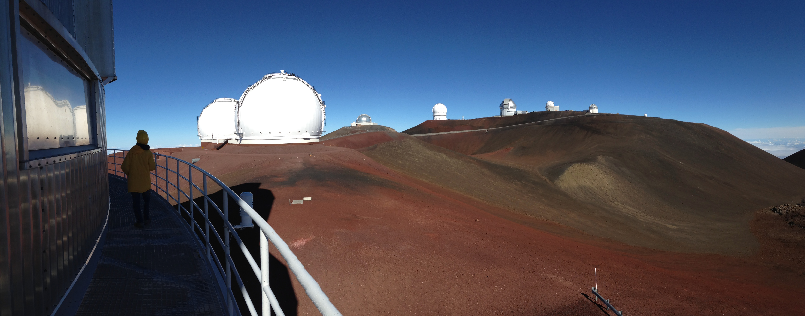
Mr. Makoto AOYAMA joined Japan Society for the Promotion of Science (JSPS) in 2011, and served Research Program Department, Policy Planning Department, and International Program Department. He obtained Bachelor of Social Psychology, the University of Tokyo, Japan, in 2011. He was assigned to the current position, Deputy Director, JSPS Bonn Office in October 2019.

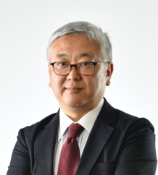
Prof. Dr. Hirofumi KATO is an archaeologist and anthropologist. Graduated from the doctoral program of institute of history and anthropology, University of Tsukuba in 1996. His major interests are prehistoric archaeology and Indigenous archaeologies. From 2001, he was associate professor of department of northern culture studies, graduate school of letters at Hokkaido University. In 2010, he moved to centre for Ainu and Indigenous studies at Hokkaido University. Then, he became a director of Russian office of Hokkaido University in Moscow from 2018. Also, he has been a director of centre of Ainu and Indigenous studies at Hokkaido University from 2020.

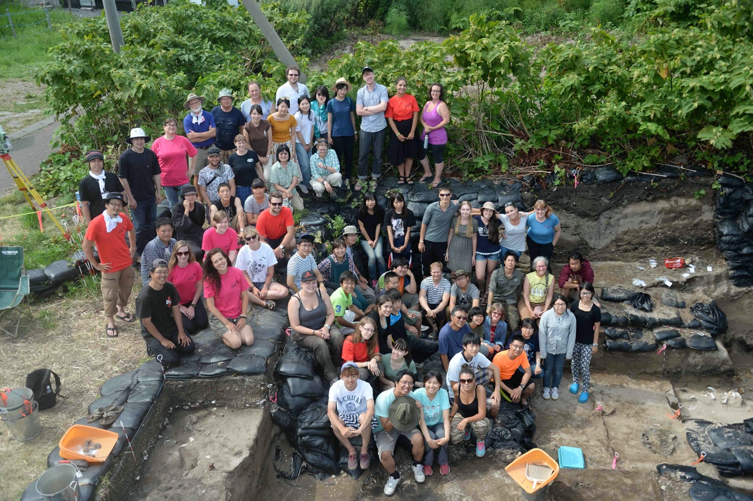

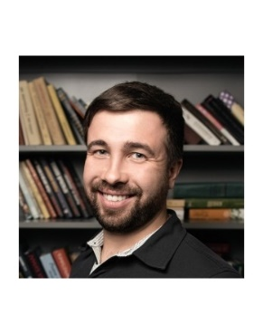
Asso. Prof. Dr. Alexander Raevskiy is associate professor at the Faculty of Psychology, Moscow State University. He graduated from Department of Japanese language of Institute of Asian and African studies (MSU) and took part in probation and research programs at Tokai University and Waseda University.
From 2010 he has been a lecturer at the Faculty of Psychology, MSU, and in 2015 he obtained a PhD. degree in psychology. In 2017 – 2019 he was a Head of Department of Psychology of Language at the Faculty of psychology, but then was invited to Tohoku University.
Currently he is a lecturer and a researcher at the department of psychology of Tohoku University. His major interests are psycholinguistics, experimental psychology and cross-cultural studies.

